**NO CALCULATORS! My Name is ___­­______________________**

**Pre-Calculus Practice and I love SLEEP! Period___**

**PRACTICE TEST CHAPTER 1.5 thru 1.9**

|  |
| --- |
| 1. Increasing |
| Decreasing |
| Constant |
| Relative Maximum |
| Relative Minimum |
| Zeros |
| $$f(-9)$$ |
| $$f(5)$$ |

10 Analyzing Graphs

**ANSWERS**

1. For each problem identify the intervals where the function is increasing, decreasing and constant and points of relative maximum and minimum and zeros.

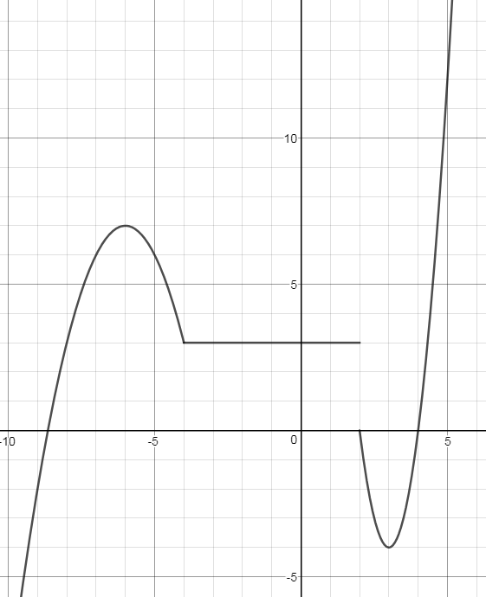

|  |
| --- |
| 2. |
| 3. |
| 4. |

4 Odd or Even

For problems 2-4, determine whether the given function is even, odd, or neither.

1. 

1.  4. 

11 Effect of Transformations on graph

|  |
| --- |
| 5.a)  1. __________  2. ______________  3. ______________ |
| 5.b)  1. ______________  2. ______________  3. ______________ |
| 5.c)  1. ______________  2. ______________  3. ______________ |

5. The graph of  has the following three points:

1)  2)  3) 

Give the new coordinates of the three points for each of the new functions.

a)  map = ( x , y )

b)  map = ( x , y )

c)  map = ( x , y )

|  |
| --- |
| 6.  (a)  (b)  (c)  (d) |
| 7.  (a)  (b)  (c)  (d) |
| 8.  (a)  (b)  (c)  (d) |

12 Operations on Functions & Composite Functions

In problem 8, for the given functions *f* and *g*, find:

(a)  (b)  (c)  (d) 

1. ; 

In problem 9, for the given functions *f* and *g*, find:

a)  b)  c)  d) 

1. ; 

In problem 10, for the pair of functions find:

(a)  (b)  (c)  (d) 

1. ; 

13 Inverse Functions

|  |
| --- |
| 9. |
| 10. |
| 11. |
| 12.  (a)  (b)  (c) |

Find the Inverse function.

9. 

10. 

11. 

|  |  |  |  |  |  |
| --- | --- | --- | --- | --- | --- |
| *x* | 2 | 3 | 4 | 5 | 6 |
| *f(x)* | -3 | -2 | -1 | 0 | 1 |

Find the following given , the table of *f(x)*, and *g(x)* has the following points .

12. a) b)  c) 

13. Graph the Inverse Function.

